Edible playgrounds landscape contractors – express your interest
Project Brief
Trees for Cities (TfC) is the only UK charity working at a national and international scale to improve lives by planting trees in cities. We get stuck in with local communities to cultivate lasting change in their neighbourhoods – whether it’s revitalising forgotten spaces, creating healthier environments or getting people excited about growing, foraging and eating healthy food.
Edible Playgrounds transform school grounds into vibrant outdoor teaching gardens that inspire hands-on learning and get children excited about growing and eating healthy food. They help improve health and wellbeing, open up access to nature, and provide a fun outdoor learning environment that supports cross-curriculum teaching.
The Edible Playgrounds programme offers a comprehensive service comprising engagement of the whole school community, design, build, planting with pupils, teacher training, and planning support throughout the academic year.
The uniqueness and value of the programme lies in embedding food-growing into the school curriculum across all subjects so that teachers learn to teach through gardening, not to become gardeners themselves. This approach builds teachers’ skills and confidence to use Edible Playground in fresh, innovative ways as an outdoor teaching resource.
We are looking for expressions of interest from Landscape Contractors to construct around 30 Edible Playgrounds across the UK.
The project
Trees for Cities have teamed up with a number of leading partners to deliver the project.
It will require the delivery of approximately 30 small-scale food growing areas. The aim is that a standard, modular system of raised timber sleeper beds will be installed in each project with a few bespoke (mainly timber) raised beds and other items added into each school project e.g. external white boards, pergolas, decking and miscellaneous features. See Figures 1-3 below to illustrate a typical TfC approach.
We are looking for a Landscape Contractor() who have the capacity and skills to deliver regional packages of simple projects delivered to a very high quality, with the end users always in mind. They will be supported by TfCs’ in house teams as follows:
- TfCs’ Design Team who will produce the plans and specifications and act as Contract Administrator;
- TfC’s Landscape Team will ensure the delivery follows the protocols developed by our own in building team and spend some time up front and throughout the project with the contractor; and
- TfC’s Edible Playgrounds Team who after practical completion will train teachers and pupils on how to use the growing spaces for up to one year.
Time frame
The delivery project will commence in Spring 2019 and run for up to one full year to March 2020 at the latest.
There are ambitions for the project to become a multi-year offer and the contract may undergo review and renewal at the end of that period of time. This may expand areas in to other UK towns and cities.
The contractor
The appointed contractor(s) should have a proven track record in delivering landscape schemes in schools and be able to demonstrate the correct protocol of working in places where there may be contact with children and vulnerable young people.
We seek landscape contractor(s) who will be able to programme manage delivery across each identified school in the region, to ensure they are populated adequately with labour and materials so that the agreed programme is adhered to and that quality is maintained throughout. Each project will be released over an agreed time frame (circa 10 months) to allow for completed designs and to work with the schools own needs.
Particular skills are needed in delivering high quality, repetitive modular timber work as the bulk of the projects will be timber construction using a sustainably sourced untreated green oak.
Scope and budget
The project will be released as 4 regional packages and contractors are invited to submit a quote for their preferred packages. Costs for labour and materials per Edible Playground project are circa £15,000 and costs for the smaller Edible Playgrounds will be approximately £6,500. Each package is likely to cover the following regional distribution and numbers. Project packages will be determined by the funding sign offs and
- Package 1 NE England– circa 10 Edible Playground projects
- Package 2 Midlands – circa 10 Edible Playground Projects
- Package 3 London and South East – about 8 Edible Playground projects
- Package 4* South Wales –4 Edible Playground projects
*Package 4 could be carried out by a small organisation or as part of one of the other packages of work where a contractor has UK wide reach.

delivery schedule
- Out for EOI WB 11th February for 2 weeks
- EOI return date 1st March 2019
- Shortlist tender invite WB 4th March 2019
- Tender returns 29th March 2019
- Appoint Contractor Mid April 2019
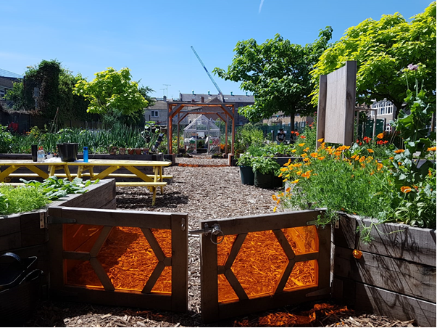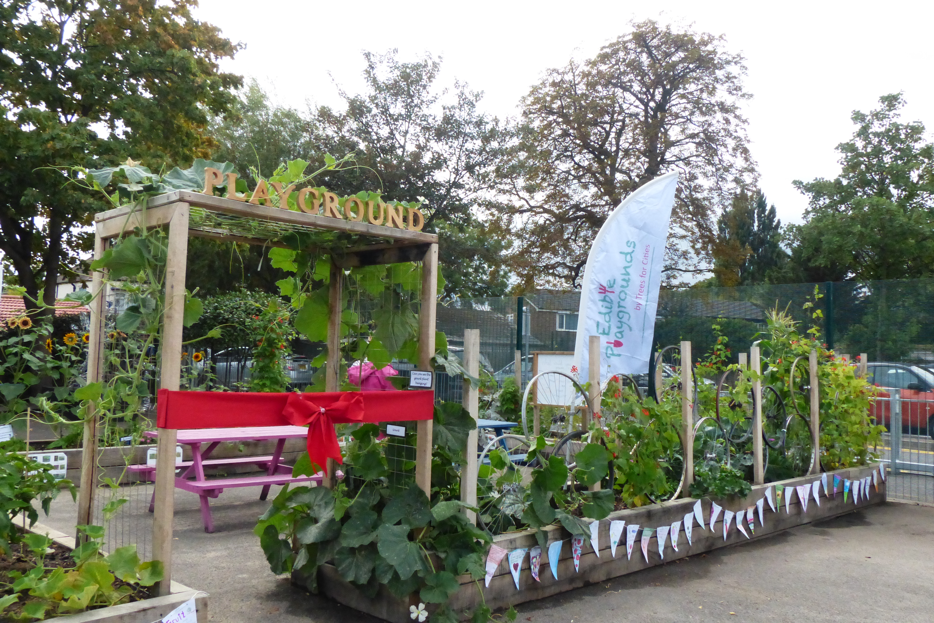
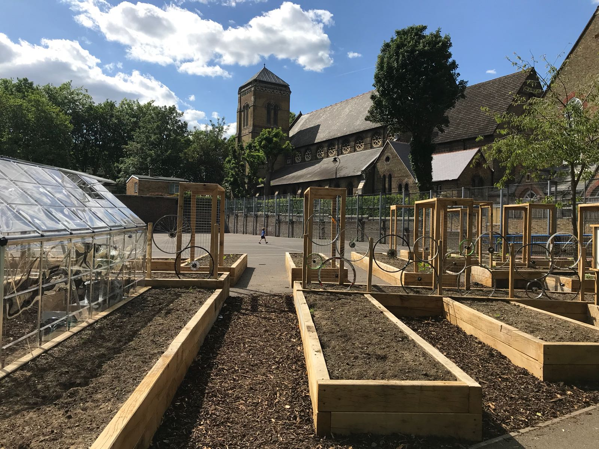
Figures 1-2 London Edible Playgrounds – typical raised bed construction details.

Next Steps
All interested parties to provide the following in their expression of interest:
- Identify and state the packages of work they can effectively achieve in the time frame given and to meet their operational scope, capacity and scale so if the contractor is able to deliver all 4 packages, please state. There is no guarantee that all 4 packages will be offered to a single contractor.
- Produce a method statement no more than a single page of A4 words explaining how you would deliver the required numbers of edible playgrounds within deadlines, to the standards and quality required and how they would efficiently address supply, delivery and installation. This would take into consideration that the sites will be identified and released for construction at phased stages over the first half of a one year project.
- Confirm that if shortlisted you be able to submit a more detailed tender and would be available to carry out the work within the deadlines stated if successful.
Interested organisations should return expressions of interest no later than 12 noon on Friday 1st March 2019, addressed to Suzanne Simmons Project Director, Trees for Cities Prince Consort Lodge, Kennington Park, Kennington Park Place, London SE11 4AS or via email to suzanne@treesforcities.org;
All pre-submission queries to be issued in writing via email address above no later than Friday 22nd February 2019

