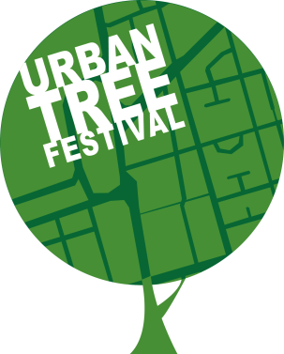

Applicants under the age of 18: Parents and Guardians

By signing you are agreeing that the video submitted may be used by The Urban Tree Festival and Trees for Cities to promote and celebrate urban trees. It may be used on social media platforms, in funding reports and on the organisations’ websites. Only your child’s first name will be used. For more information please visit: [www.treesforcities.org/urbantreefestival](http://www.treesforcities.org/urbantreefestival) or contact [jess@treesforcities.org](mailto:jess@treesforcities.org)

Parent / Guardian Full Name:

Parent / Guardian Email Address:

Relationship to child or young person:

Notes:

**First name:**

**Last name:**

**Date of birth:**

**Town / city:**

**Country:**

**Email address:**

**How did you hear about this opportunity?**

**What gender pronoun(s) do you use?**

*This question is optional*

**Do you give The Urban Tree Festival and Trees for Cities permission to share your video on social media platforms, websites and reports to celebrate and promote urban trees?**

*Please write yes or no.*

**Urban Tree Festival: Video submission form**